**Test Amazon SQS using AWS Lambda**

**1. Create an Amazon SQS queue**

1. Login to AWS console - <https://console.aws.amazon.com>
2. Type **SQS** in the Services search box and select **Amazon SQS**
3. On the **SQS** console home, click **Create New Queue** or click **Get started**
4. Enter **<Your_Name>-LabQueue.fifo** in the **Queue Name** textbox.
5. Select **FIFO Queue** under **What type of queue do you need?
6. Scroll down and click **Quick-Create Queue**
7. Your queue is now successfully created.
8. Copy the **URL** from the **Details** tab at the bottom of the screen and save it in a text editor. We will use this URL in the Lambda function we will create later.

**2. Create a Python based Lambda function to send messages to SQS**

1. Navigate to AWS Lambda
2. Click on **Create function**
3. Select **Author from scratch**
4. Name the funcion as **<Your_Name>-sendmessage**
5. Select **Python 3.6** as the runtime
6. Click **Create function**
7. Replace the default code with the code in the block below

|  |
| --- |
| import json  import boto3  def lambda_handler(event, context):  sqs_queue_url="<QUEUE_URL>"    sqs_client = boto3.client('sqs')    msg = sqs_client.send_message(QueueUrl=sqs_queue_url,MessageBody=event,MessageGroupId='mygroup',MessageDeduplicationId='dedupeID',  ) |

1. Replace **<QUEUE_URL>** with the URL you saved into the text editor earlier
2. Click on **Save** at the top of the screen to save the code changes you just made.
3. Scroll down to the **Execution role** section on the Lambda console. You will see that a new IAM Role has been created for the Lambda function with some basic permissions as shown in the screenshot below. [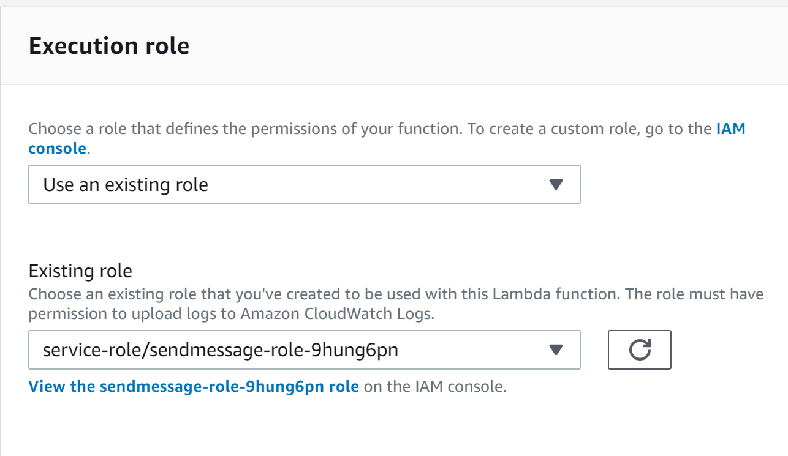](https://github.com/awsimaya/lab-LambdaSQSTest/blob/master/images/IAM.png)
4. For the Lambda function to be able to send messages to the SQS queue, it needs to have necessary permissions. Click on **View the sendmessage-role-...** link which will open a new tab and take you to the IAM console.
5. Click on **Attach policies**
6. Type **sqs** in the search textbox and select **AmazonSQSFullAccess** policy checkbox
7. Click **Attach policy**. Once the policy is saved, close the browser tab.

**3. Create a Python based Lambda function to read messages from the Queue**

1. Navigate to **AWS Lambda** console and click **Create function**
2. Name the function as **readmessage**
3. Select **Python 3.6** as the runtime
4. Expand **Choose or create an execution role** by clicking on it
5. Select **Use an existing role** under **Execution role** section
6. Select the same role you created earlier for the **<Your_Name>-sendmessage** lambda function. See screenshot below for details [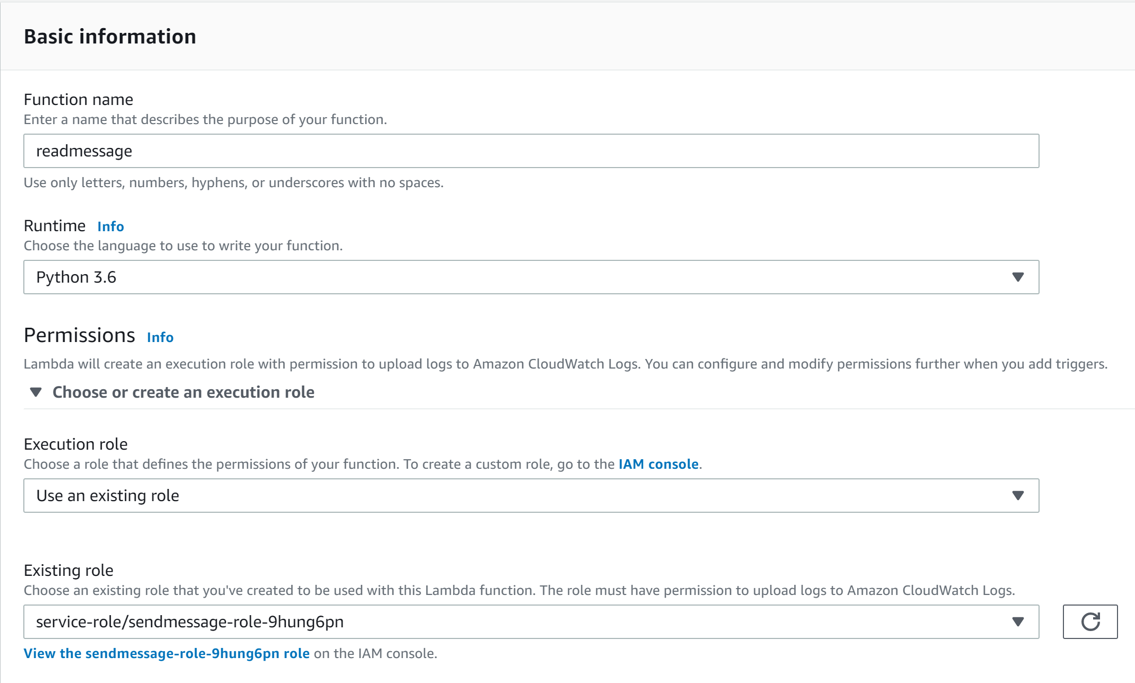](https://github.com/awsimaya/lab-LambdaSQSTest/blob/master/images/readmessage.png)
7. Click **Create function**
8. Replace the default code with the code below and click the **Save** button at the top right to save the changes

|  |
| --- |
| import json  import boto3  def lambda_handler(event, context):  # Retrieve messages from an SQS queue  sqs_queue_url = "<QUEUE_URL>"  sqs_client = boto3.client('sqs')  msgs = sqs_client.receive_message(QueueUrl=sqs_queue_url)    print(msgs) |

1. Replace **<QUEUE_URL>** with the URL of the queue you created earlier in the exercise

**Test everything**

**Send message to the SQS queue**

1. Navigate to the **<Your_Name>-sendmessage** Lambda function page
2. Click on the drop down near the **Test** button at the top right and select **Configure test events**
3. In the new popup, select **Create new test event**
4. Select **Hello World** template.
5. Name the event as **<Your_Name>-newmessage**
6. Clear the textbox with sample inpute json and enter any string within quotes. See screenshot below for details [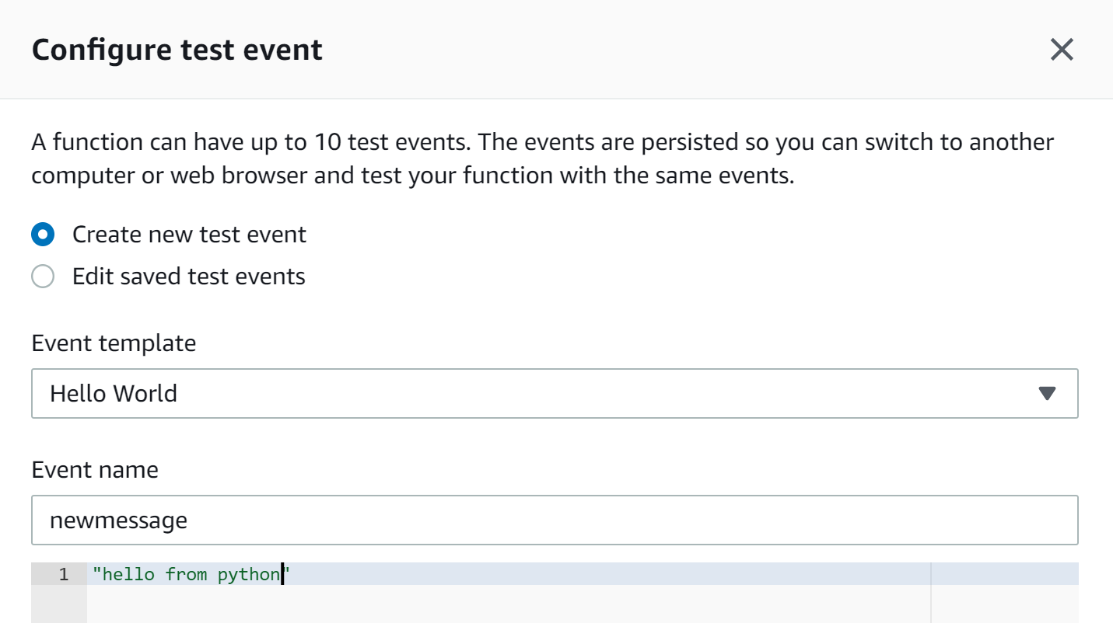](https://github.com/awsimaya/lab-LambdaSQSTest/blob/master/images/inputtext.png)
7. Click **Save** at the bottom of the screen
8. Simply click on the **Test** button on the **<Your_Name>-sendmessage** Lambda function home page to send the message to SQS
9. You should see the user interface saying **Execution result:succeeded**. Click on it to see details of the execution.

**Check the message in SQS queue**

1. Navigate to Amazon SQS home page and select **LabQueue.info**
2. Click on **Send and receive messages** and click **Poll for messages**
3. You should be able to see the message that you just sent from the Lambda function.

**Read the message from the SQS queue**

1. Navigate to the **<Your_Name>-readmessage** Lambda function page
2. Click on the drop down near the **Test** button at the top right and select **Configure test events**
3. In the new popup, select **Create new test event**
4. Select **Hello World** template.
5. Name the event as **readmessage**
6. Clear the textbox with sample inpute json and replace it with empty quotes [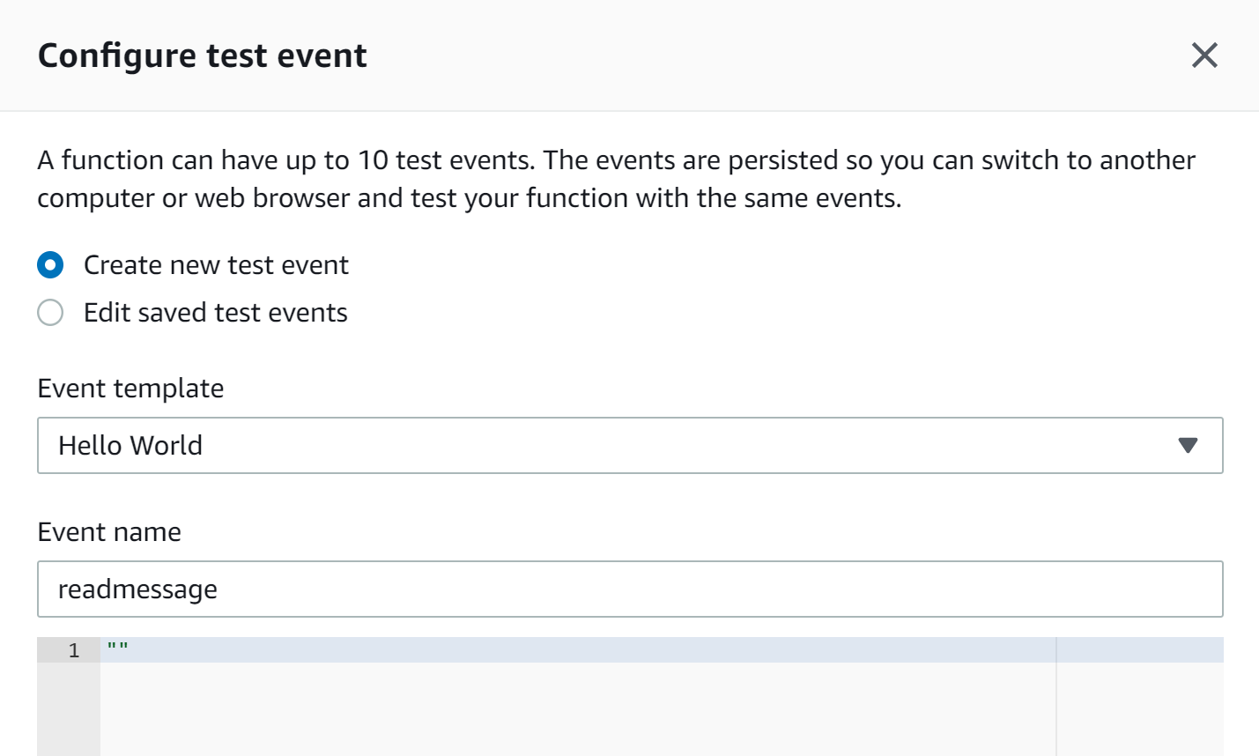](https://github.com/awsimaya/lab-LambdaSQSTest/blob/master/images/output.png)
7. Click **Save** at the bottom of the screen
8. Simply click on the **Test** button on the **<Your_Name>-readmessage** Lambda function home page to send the message to SQS
9. You should see the user interface saying **Execution result:succeeded**. Expanding it will show the details of the execution along with the content of the SQS message in the **Log output** section.